|  |  |  |
| --- | --- | --- |
| iublogo | The Islama University of Bahawalpur  **Department of Information Technology**  **Software Design Document (SDD)**  ClassNet – LAN-Based Offline Classroom System | itlogo |

Version 1.0  
  
**Submitted By:**

|  |  |  |  |
| --- | --- | --- | --- |
| **Name** | **Roll No** | **Role** | **Session** |
| Muhammad Hamza | F22BINFT1M01128 | Front-end Developer | 2022-2026 |
| Talha Bilal | F22BINFT1M01103 | Back-end Developer | 2022-2026 |

# 1. Introduction

## 1.1 Purpose

This Software Design Document (SDD) describes the architecture and design of the FYP-ClassNet system. It provides a comprehensive overview of the system's structure, components, interfaces, and data flows. This document is intended for:

* Software developers implementing the system
* System architects reviewing the design
* Quality assurance teams validating implementation
* Maintenance teams supporting the system

## 1.2 Scope

FYP-ClassNet is a web-based classroom collaboration platform designed to operate over local area networks without internet connectivity. The system architecture consists of:

* React-based frontend for user interfaces
* Node.js backend for business logic and API services
* SQLite database for data persistence
* WebRTC infrastructure for real-time screen sharing
* Socket.io for bidirectional communication
* Docker containerization for deployment

## 1.3 Overview

This document is organized into the following sections:

* Section 2: System Overview - high-level architecture
* Section 3: System Architecture - detailed architectural design
* Section 4: Data Design - database schema and data structures
* Section 5: Component Design - detailed component specifications
* Section 6: User Interface Design - UI/UX specifications
* Section 7: Deployment Architecture - containerization and deployment

## 1.4 Definitions and Acronyms

|  |  |
| --- | --- |
| **Term** | **Definition** |
| **API** | Application Programming Interface |
| **REST** | Representational State Transfer |
| **WebRTC** | Web Real-Time Communication |
| **Socket.io** | JavaScript library for real-time web applications |
| **CRUD** | Create, Read, Update, Delete operations |
| **JWT** | JSON Web Token |
| **MVC** | Model-View-Controller pattern |
| **SPA** | Single Page Application |
| **ORM** | Object-Relational Mapping |

# 2. System Overview

## 2.1 System Context

FYP-ClassNet operates as a standalone web application within a local area network. The system consists of:

Server Component:

* Hosted on teacher's laptop/desktop computer
* Runs Node.js backend and serves React frontend
* Manages all business logic and data storage
* Coordinates real-time communication

Client Component:

* Browser-based application (no installation required)
* Accesses server via local IP address
* Provides interfaces for teachers and students
* Handles WebRTC peer connections

## 2.2 Design Considerations

### 2.2.1 Assumptions

* Local network infrastructure (WiFi router or hotspot) is available
* All devices are connected to the same LAN
* Teacher device has sufficient resources to run the server
* Client devices support modern web standards

### 2.2.2 Constraints

* No internet connectivity required or assumed
* Must use lightweight technologies suitable for resource-constrained environments
* Must support at least 50 concurrent connections
* Real-time features must have sub-second latency

### 2.2.3 System Dependencies

* Node.js runtime (v18.0+)
* React library (v18.0+)
* SQLite database (v3.35+)
* Socket.io (v4.0+)
* Express.js (v4.18+)
* Docker (v20.10+) for containerized deployment

# 3. System Architecture

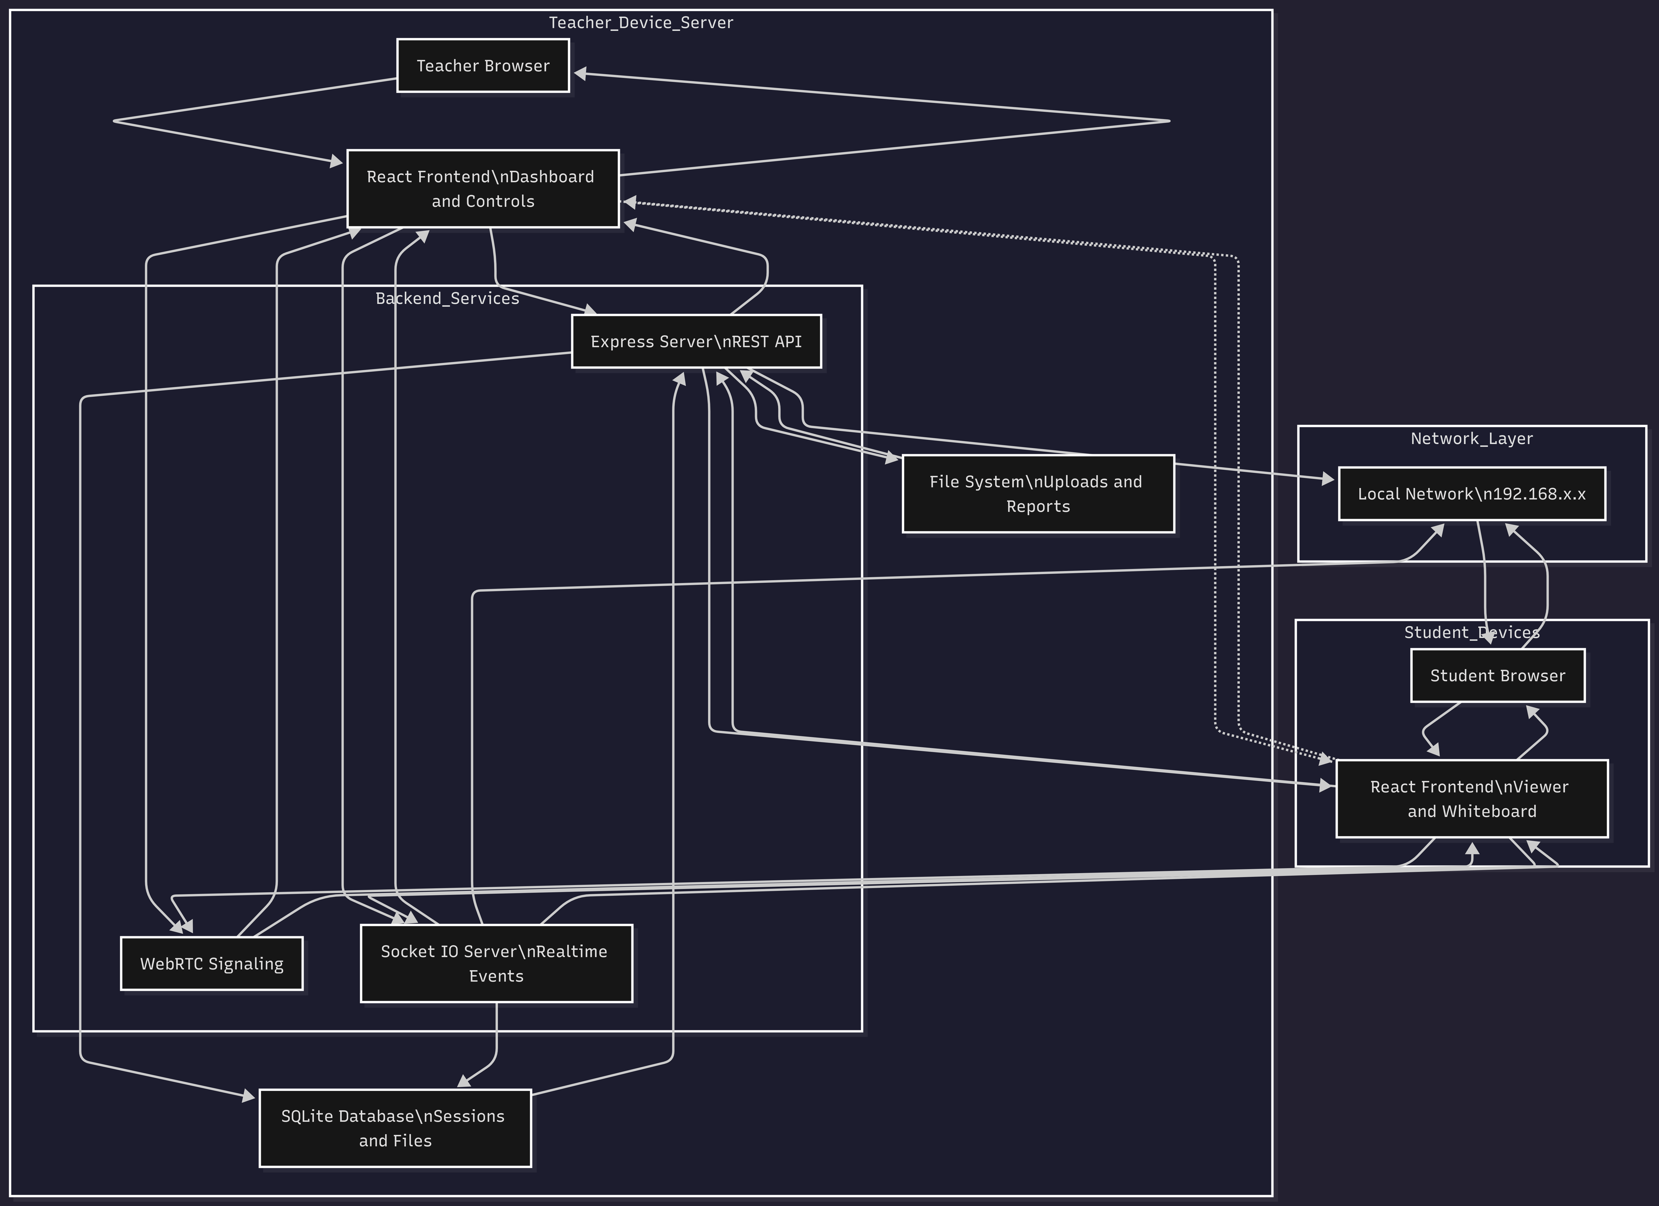

## 3.1 Architectural Design

FYP-ClassNet follows a three-tier architecture pattern:

### 3.1.1 Presentation Layer

Technology: React 18.x

Responsibilities:

* Render user interfaces for teachers and students
* Handle user interactions and input validation
* Manage client-side state using React Context/Redux
* Establish WebRTC and Socket.io connections

Key Components:

* TeacherDashboard: Main control panel for teachers
* StudentView: Content viewing interface for students
* SessionJoin: Session connection interface
* Whiteboard: Interactive drawing canvas
* FileManager: File upload/download interface

### 3.1.2 Application Layer

Technology: Node.js with Express.js

Responsibilities:

* Implement business logic and application rules
* Provide RESTful API endpoints
* Handle WebSocket connections via Socket.io
* Coordinate WebRTC signaling
* Manage file uploads and downloads
* Authenticate and authorize requests

Key Modules:

* SessionController: Session lifecycle management
* AttendanceController: Attendance tracking and reporting
* FileController: File storage and retrieval
* WebRTCSignalingService: WebRTC connection coordination
* SocketService: Real-time event handling

### 3.1.3 Data Layer

Technology: SQLite 3.x

Responsibilities:

* Persist application data
* Provide data access interface
* Maintain data integrity and consistency
* Support concurrent access

Data Access Pattern:

* Repository pattern for database operations
* SQL query builder for complex queries
* Transaction support for critical operations

## 3.2 Communication Architecture

### 3.2.1 HTTP/REST API

Purpose: Standard CRUD operations and resource management

Endpoints:

* POST /api/sessions - Create new session
* GET /api/sessions/:id - Get session details
* DELETE /api/sessions/:id - End session
* GET /api/sessions/:id/attendance - Get attendance list
* POST /api/files/upload - Upload file
* GET /api/files/:id/download - Download file

### 3.2.2 WebSocket (Socket.io)

Purpose: Real-time bidirectional communication

Events:

* student-joined: Notify when student connects
* student-left: Notify when student disconnects
* whiteboard-update: Synchronize whiteboard changes
* screen-share-start: Initiate screen sharing
* screen-share-stop: Terminate screen sharing

### 3.2.3 WebRTC

Purpose: Peer-to-peer screen sharing

Flow:

* 1. Teacher initiates screen capture
* 2. Server coordinates signaling between teacher and students
* 3. WebRTC peer connections established
* 4. Video stream transmitted directly (peer-to-peer when possible)
* 5. Server acts as TURN server fallback if needed

# 4. Data Design

## 4.1 Database Schema

### 4.1.1 Sessions Table

Stores information about classroom sessions

|  |  |  |  |
| --- | --- | --- | --- |
| **Column** | **Type** | **Constraints** | **Description** |
| **session_id** | INTEGER | PRIMARY KEY | Unique session identifier |
| **session_code** | TEXT | UNIQUE, NOT NULL | 6-digit alphanumeric code |
| **session_name** | TEXT | NOT NULL | Human-readable session name |
| **subject** | TEXT |  | Course/subject name |
| **teacher_ip** | TEXT |  | Server IP address |
| **created_at** | DATETIME | NOT NULL | Session start timestamp |
| **ended_at** | DATETIME |  | Session end timestamp |
| **status** | TEXT | NOT NULL | active, paused, ended |

### 4.1.2 Attendance Table

Tracks student participation in sessions

|  |  |  |  |
| --- | --- | --- | --- |
| **Column** | **Type** | **Constraints** | **Description** |
| **attendance_id** | INTEGER | PRIMARY KEY | Unique attendance record ID |
| **session_id** | INTEGER | FOREIGN KEY | References sessions.session_id |
| **student_name** | TEXT | NOT NULL | Student name |
| **student_ip** | TEXT | NOT NULL | Student device IP address |
| **join_time** | DATETIME | NOT NULL | When student joined |
| **leave_time** | DATETIME |  | When student left |
| **status** | TEXT | NOT NULL | connected, disconnected |

### 4.1.3 Files Table

Manages shared files

|  |  |  |  |
| --- | --- | --- | --- |
| **Column** | **Type** | **Constraints** | **Description** |
| **file_id** | INTEGER | PRIMARY KEY | Unique file identifier |
| **session_id** | INTEGER | FOREIGN KEY | References sessions.session_id |
| **file_name** | TEXT | NOT NULL | Original filename |
| **file_path** | TEXT | NOT NULL | Server file system path |
| **file_size** | INTEGER | NOT NULL | File size in bytes |
| **file_type** | TEXT |  | MIME type |
| **uploaded_at** | DATETIME | NOT NULL | Upload timestamp |

### 4.1.4 Whiteboard_States Table

Stores whiteboard snapshots

|  |  |  |  |
| --- | --- | --- | --- |
| **Column** | **Type** | **Constraints** | **Description** |
| **state_id** | INTEGER | PRIMARY KEY | Unique state identifier |
| **session_id** | INTEGER | FOREIGN KEY | References sessions.session_id |
| **state_data** | TEXT | NOT NULL | JSON-encoded whiteboard state |
| **saved_at** | DATETIME | NOT NULL | When state was saved |

## 4.2 Data Flow Diagrams

### 4.2.1 Session Creation Flow

1. Teacher submits session creation request via UI

2. Frontend sends POST request to /api/sessions

3. Backend generates unique session code

4. Backend inserts record into Sessions table

5. Backend returns session details (code, IP) to frontend

6. Frontend displays session information to teacher

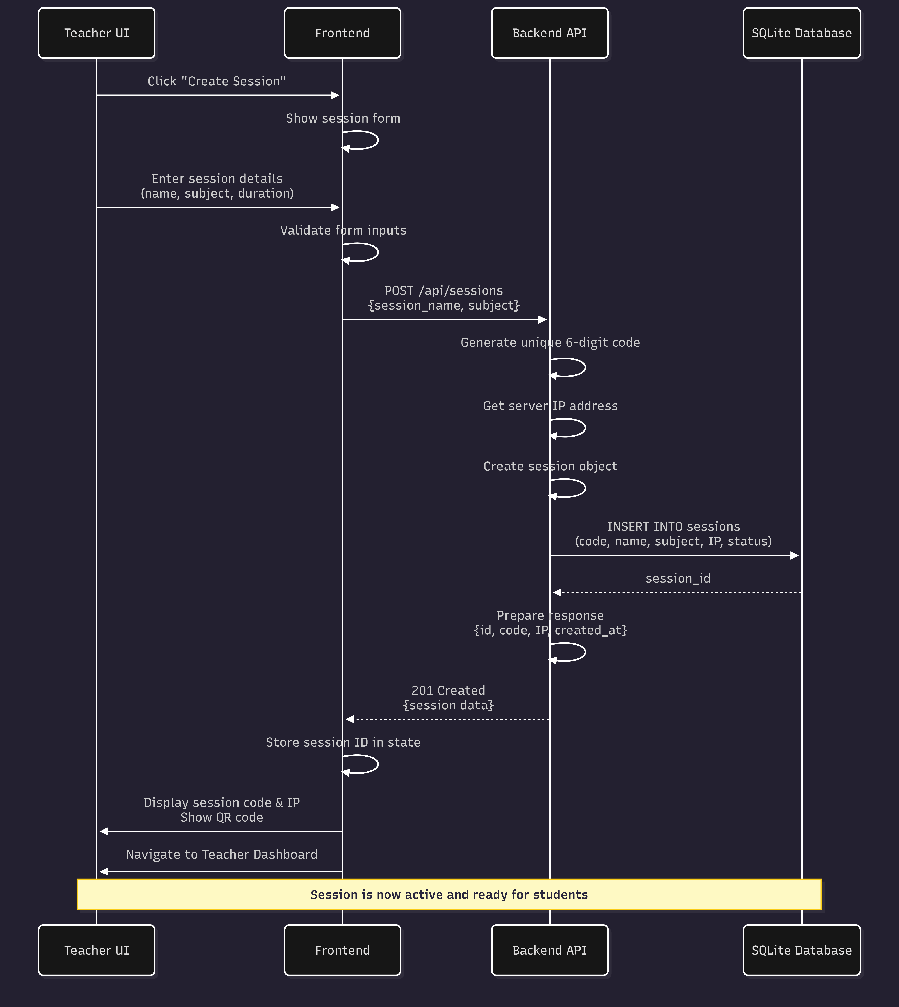

### 4.2.2 Student Join Flow

1. Student enters session code/IP and name in UI

2. Frontend validates input and sends join request

3. Backend validates session code and availability

4. Backend extracts student IP address from request

5. Backend inserts attendance record into database

6. Backend establishes Socket.io connection

7. Backend broadcasts 'student-joined' event to teacher

8. Frontend redirects student to session view



### 4.2.3 Screen Share Flow

1. Teacher clicks 'Share Screen' button

2. Frontend requests screen capture permission

3. Frontend obtains MediaStream from screen

4. Frontend signals server via Socket.io

5. Server broadcasts 'screen-share-start' to all students

6. Students initiate WebRTC peer connections

7. Server coordinates ICE candidate exchange

8. Peer 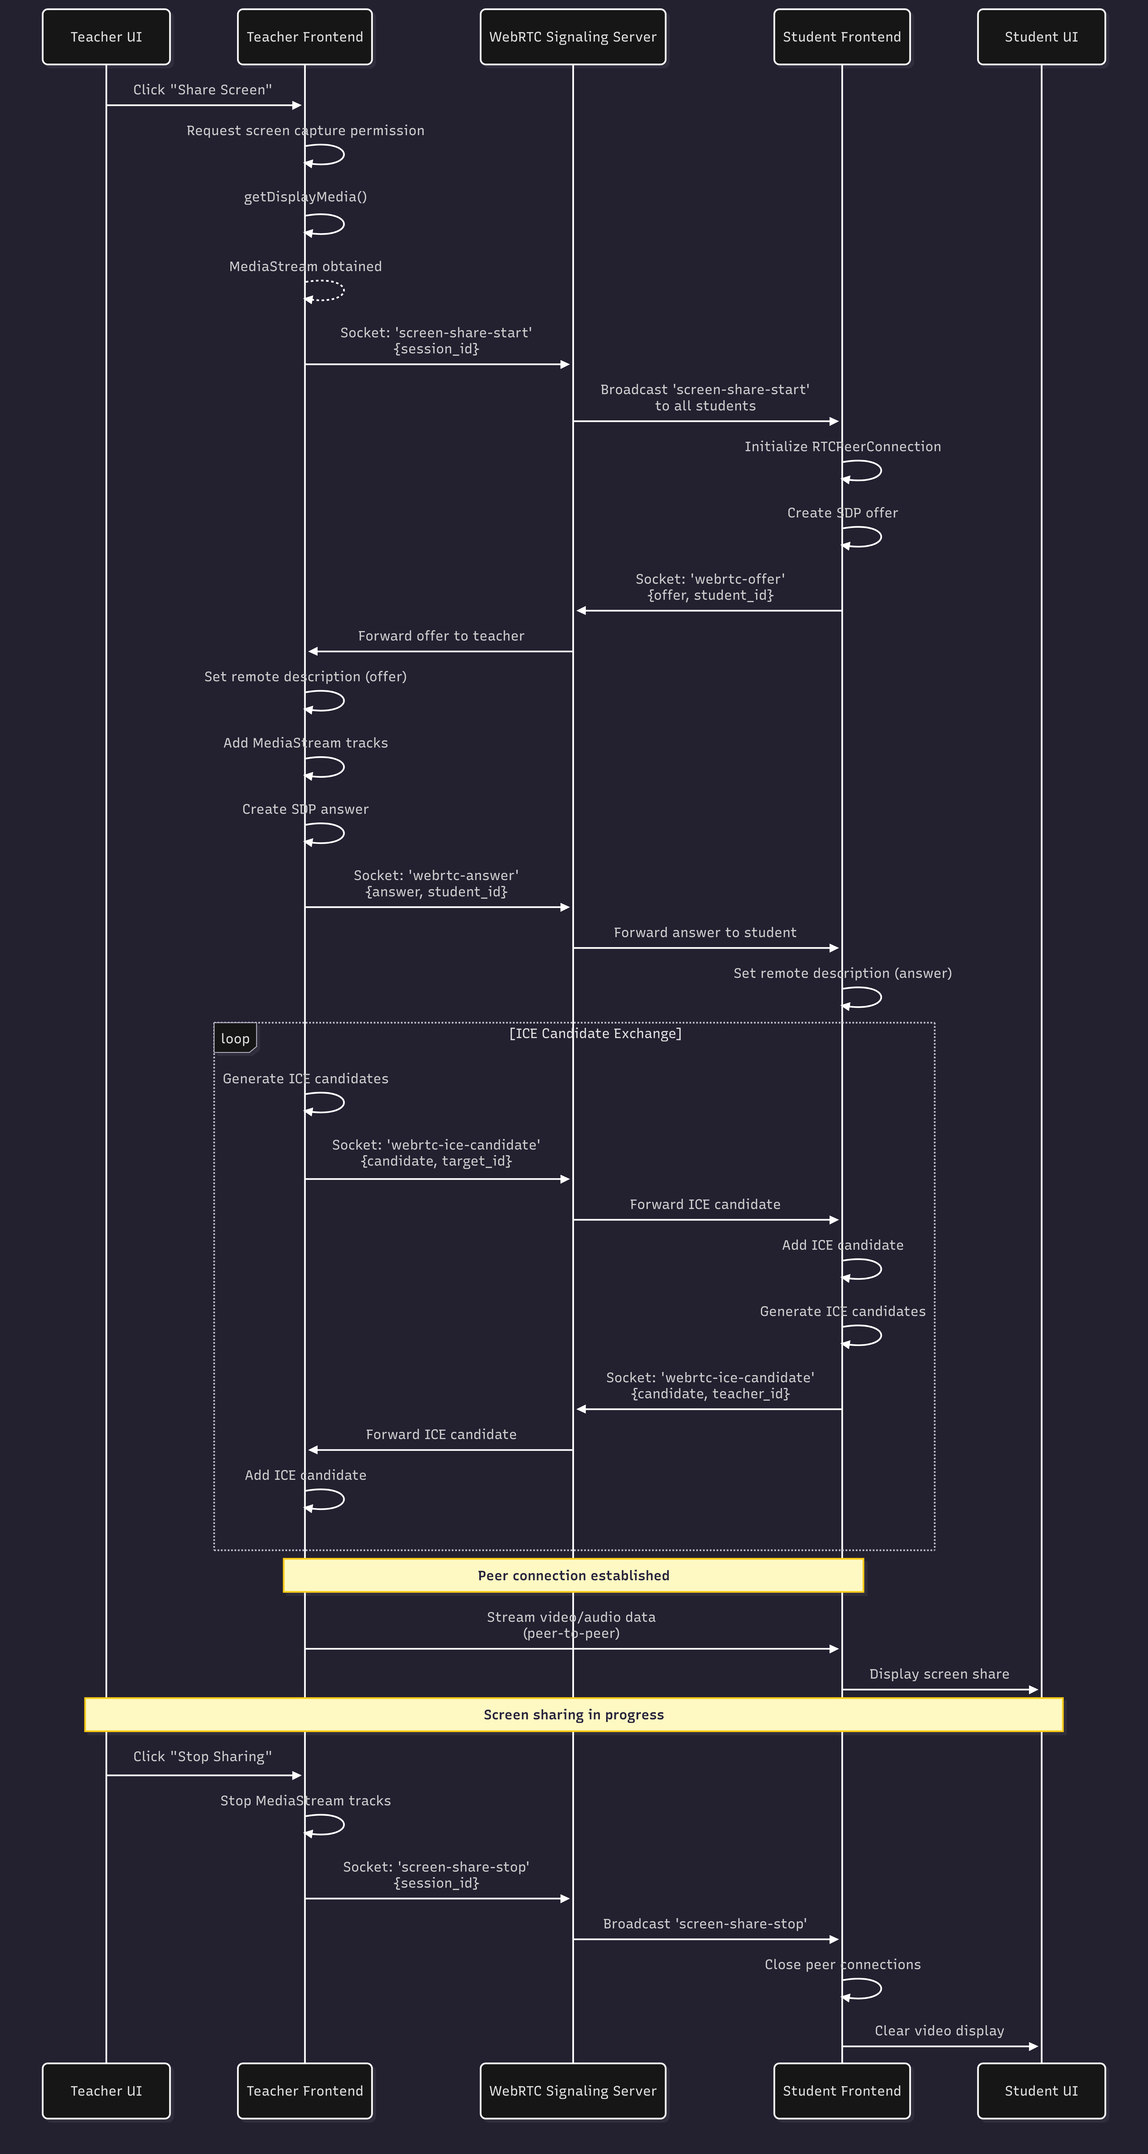connections established, video stream flows

# 5. Component Design

## 5.1 Frontend Components

### 5.1.1 Teacher Dashboard Component

Purpose: Main interface for teachers to manage sessions

Props:

* sessionId: string - Current active session ID
* onEndSession: function - Callback to end session

State:

* connectedStudents: array - List of active students
* isScreenSharing: boolean - Screen share status
* sharedFiles: array - List of uploaded files

Methods:

* startScreenShare() - Initiate screen sharing
* stopScreenShare() - Stop screen sharing
* uploadFile(file) - Upload file to session
* exportAttendance() - Download attendance report

### 5.1.2 Student View Component

Purpose: Interface for students to view shared content

Props:

* sessionId: string - Joined session ID
* studentName: string - Student's name

State:

* screenStream: MediaStream - Received video stream
* availableFiles: array - Files shared by teacher
* whiteboardState: object - Current whiteboard state

Methods:

* downloadFile(fileId) - Download shared file
* requestHelp() - Raise hand / ask question

### 5.1.3 Whiteboard Component

Purpose: Interactive drawing canvas

Props:

* sessionId: string - Associated session
* isTeacher: boolean - Teacher or student mode
* socket: Socket - Socket.io connection

State:

* drawingData: array - Collection of drawing strokes
* selectedTool: string - Current tool (pen, eraser, etc.)
* selectedColor: string - Current drawing color
* lineWidth: number - Stroke thickness

Methods:

* handleMouseDown(event) - Start drawing
* handleMouseMove(event) - Continue drawing
* handleMouseUp(event) - Finish stroke
* emitDrawing(data) - Send drawing to server
* clearCanvas() - Clear all drawings
* saveWhiteboard() - Export as image

## 5.2 Backend Components

### 5.2.1 Session Controller

Purpose: Handle session-related API requests

Methods:

createSession(req, res)

* Input: session_name, subject
* Process: Generate session code, get server IP, insert to DB
* Output: session object with id, code, IP

getSession(req, res)

* Input: session_id or session_code
* Process: Query database for session details
* Output: session object

endSession(req, res)

* Input: session_id
* Process: Update session status, disconnect all students
* Output: success confirmation

### 5.2.2 Attendance Controller

Purpose: Manage attendance records

**Methods:**

recordJoin(sessionId, studentName, studentIp)

* Insert attendance record with join_time
* Return attendance_id

recordLeave(attendanceId)

* Update attendance record with leave_time
* Set status to 'disconnected'

getAttendance(sessionId)

* Query all attendance records for session
* Return array of student records

exportAttendance(sessionId, format)

* Generate CSV or PDF report
* Return file stream

### 5.2.3 File Controller

Purpose: Handle file upload and download

Methods:

uploadFile(req, res)

* Input: multipart/form-data with file and session_id
* Process: Save file to disk, insert record to DB
* Output: file object with id, name, size

downloadFile(req, res)

* Input: file_id
* Process: Query DB for file path, stream file
* Output: file binary stream

deleteFile(req, res)

* Input: file_id
* Process: Remove file from disk and DB
* Output: success confirmation



### 5.2.4 Socket Service

Purpose: Manage Socket.io connections and events

Events Handled:

connection

* Initialize new Socket.io connection
* Store connection in session map

join-session

* Associate socket with session room
* Broadcast 'student-joined' to teacher

whiteboard-draw

* Receive drawing data from teacher
* Broadcast to all students in session

disconnect

* Remove connection from session
* Update attendance record
* Notify teacher of disconnection

### 5.2.5 WebRTC Signaling Service

Purpose: Coordinate WebRTC peer connections

Methods:

handleOffer(socket, offer, sessionId)

* Receive SDP offer from teacher
* Forward to specific student

handleAnswer(socket, answer, teacherId)

* Receive SDP answer from student
* Forward to teacher

handleIceCandidate(socket, candidate, targetId)

* Relay ICE candidates between peers
* Support connection establishment



# 6. User Interface Design

## 6.1 UI Architecture

The UI follows a component-based architecture using React, with routing managed by React Router.

### 6.1.1 Layout Structure

Common Layout:

* Header: Application title, session info, navigation
* Main Content Area: Primary interface components
* Sidebar: Quick actions and status (conditional)
* Footer: Version info, help link

## 6.2 Screen Designs

### 6.2.1 Teacher Session Creation Screen

Purpose: Create new classroom session

Elements:

* Form with fields: Session Name, Subject, Duration
* 'Create Session' button
* List of previous sessions

Layout:

* Centered card-based design
* Form validation with inline error messages
* Success message with session code and IP displayed prominently

### 6.2.2 Teacher Dashboard Screen

Purpose: Monitor and control active session

Elements:

* Session info panel: Code, IP, duration, student count
* Student list: Names, IPs, join times, status indicators
* Control buttons: Share Screen, Open Whiteboard, Upload File, End Session
* File list: Shared files with delete options

Layout:

* Grid layout with sidebar for students list
* Main area for controls and shared content
* Real-time updates via Socket.io

### 6.2.3 Student Join Screen

Purpose: Allow students to join sessions

Elements:

* Input field for session code or IP:PORT
* Input field for student name
* 'Join Session' button
* Help text explaining how to get session code

Layout:

* Simple centered form
* Large, friendly UI with clear instructions
* Mobile-responsive design

### 6.2.4 Student Session View Screen

Purpose: Display shared content to students

Elements:

* Video container for screen share (full-screen capable)
* Tabs: Screen Share, Files, Whiteboard
* File list with download buttons
* Whiteboard viewer (read-only)
* 'Raise Hand' button (future feature)

Layout:

* Maximized content view
* Minimal chrome to maximize learning area
* Tab-based navigation between content types

### 6.2.5 Whiteboard Interface

Purpose: Interactive drawing for teacher, view-only for students

Elements (Teacher):

* Canvas area: Main drawing surface
* Tool palette: Pen, eraser, shapes, text
* Color picker
* Line width slider
* Clear, Undo, Redo, Save buttons

Elements (Student):

* Canvas area: View-only display of whiteboard
* Auto-sync indicator

Layout:

* Full-screen whiteboard with overlay toolbar
* Real-time synchronization via Socket.io

## 6.3 UI/UX Guidelines

* Use consistent color scheme across all screens
* Provide immediate feedback for user actions
* Use loading indicators for async operations
* Display clear error messages with suggested actions
* Ensure accessibility (ARIA labels, keyboard navigation)
* Support both light and dark modes (optional)
* Responsive design for desktop, tablet, and mobile

# 7. Deployment Architecture

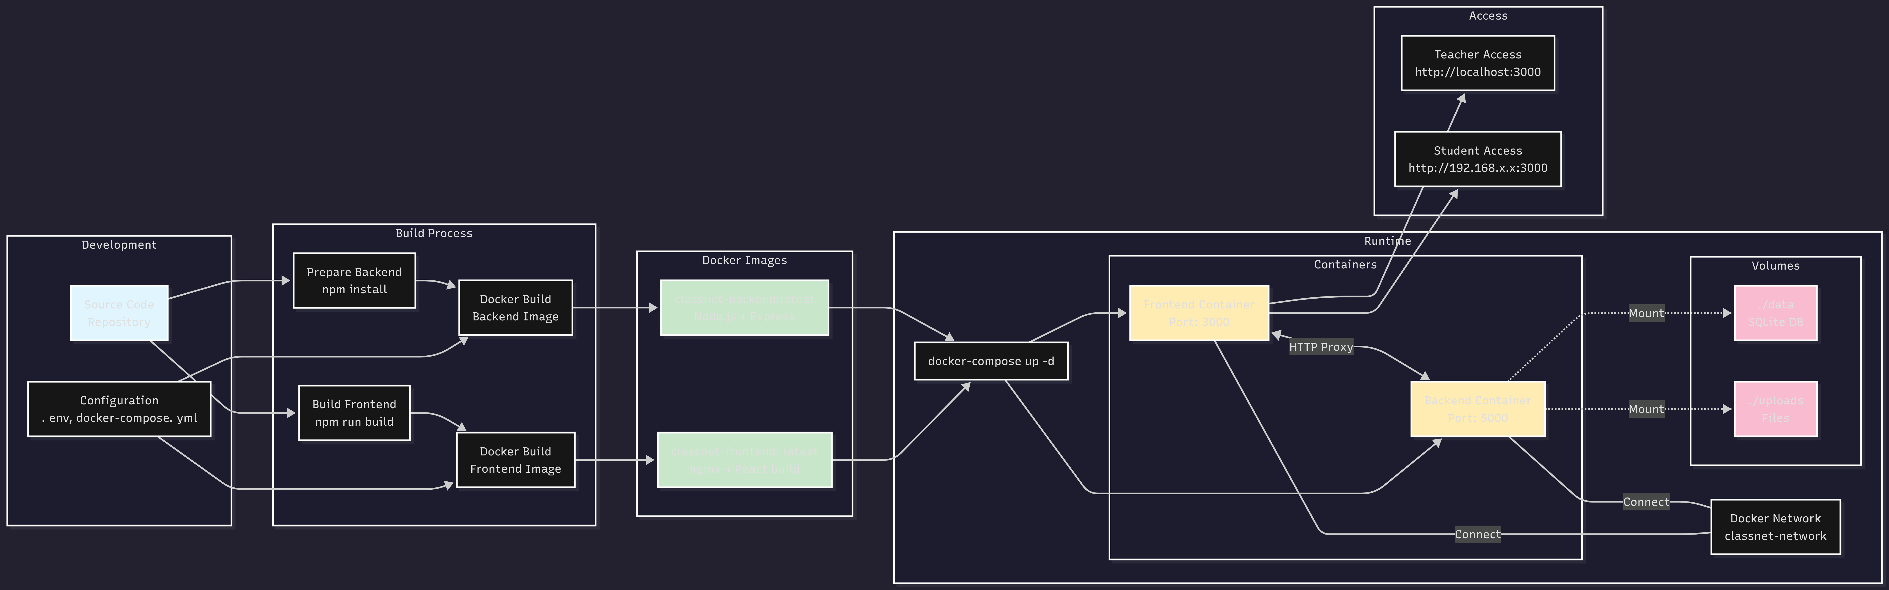

## 7.1 Docker Containerization

### 7.1.1 Backend Container

Base Image: node:18-alpine

Configuration:

* Install Node.js dependencies
* Copy backend source code
* Expose port 5000
* Volume mount for SQLite database
* Volume mount for uploaded files

**Dockerfile Structure:**

FROM node:18-alpine

WORKDIR /app

COPY package*.json ./

RUN npm install --production

COPY . .

EXPOSE 5000

CMD ["node", "server.js"]

### 7.1.2 Frontend Container

Build Stage: node:18-alpine

Production Stage: nginx:alpine

Configuration:

* Build React app in build stage
* Copy built files to nginx in production stage
* Configure nginx to serve SPA (handle client-side routing)
* Expose port 3000

## 7.2 Docker Compose Setup

Services:

* backend: Node.js API server
* frontend: Nginx serving React build

Networking:

* Backend accessible to frontend via service name
* Both services on same network
* Host network mode for LAN access

Volumes:

* ./data:/app/data - Persist SQLite database
* ./uploads:/app/uploads - Persist uploaded files

## 7.3 Deployment Scenarios

### 7.3.1 Standard Deployment

1. Install Docker on teacher's laptop

2. Clone repository or copy deployment package

3. Run: docker-compose up -d

4. Access at http://localhost:3000 or http://[LAN_IP]:3000

5. Share IP address with students

### 7.3.2 Development Deployment

1. Run backend with: npm run dev (hot reload)

2. Run frontend with: npm start (hot reload)

3. Backend on port 5000, frontend on port 3000

### 7.3.3 Production Deployment

1. Build Docker images: docker-compose build

2. Start containers: docker-compose up -d

3. Configure firewall to allow LAN access

4. Optional: Set up reverse proxy (nginx) for HTTPS

## 7.4 Network Configuration

* Ensure WiFi router/hotspot is configured correctly
* Server and clients must be on same subnet
* Typical configuration: 192.168.x.x network
* No port forwarding or DMZ needed
* Firewall should allow inbound on port 3000/5000

# 8. Security Design

## 8.1 Authentication and Authorization

Session Code Validation:

* Cryptographically random 6-digit codes
* Code validation on every student join attempt
* Codes expire when session ends

IP-Based Access Control:

* Only devices on same LAN can access server
* Track unique IP addresses to prevent duplicates
* Flag suspicious connection patterns

## 8.2 Data Security

* All data stored locally on server (no cloud transmission)
* SQLite database file protected by file system permissions
* Uploaded files stored in protected directory
* No personal data stored beyond session duration (optional cleanup)

## 8.3 Communication Security

* WebSocket connections use wss:// when HTTPS enabled
* WebRTC uses DTLS for media encryption
* Input validation on all API endpoints
* Sanitize user inputs to prevent XSS attacks

## 8.4 File Upload Security

* File type validation (whitelist approach)
* File size limits enforced (500MB max)
* Rename uploaded files to prevent path traversal
* Scan files for malware (optional with ClamAV)

# 9. Performance Design

## 9.1 Scalability Considerations

* Support for 50+ concurrent student connections
* Efficient WebRTC mesh network for screen sharing
* Socket.io rooms for session isolation
* Database indexing on frequently queried columns

## 9.2 Optimization Strategies

* Lazy loading of React components
* Compression of static assets (gzip)
* Caching of static resources in browser
* Debouncing whiteboard drawing events
* Efficient file streaming (chunked transfer)

## 9.3 Resource Management

* Automatic cleanup of ended sessions
* Periodic database optimization (VACUUM)
* Memory monitoring and garbage collection
* Connection pooling for database access

# 10. Testing Strategy

## 10.1 Unit Testing

* Backend: Jest for Node.js testing
* Frontend: Jest + React Testing Library
* Target: 80%+ code coverage
* Test database operations, API endpoints, component rendering

## 10.2 Integration Testing

* Test API endpoints with Supertest
* Test Socket.io events with socket.io-client
* Test database transactions
* Test file upload/download workflows

## 10.3 End-to-End Testing

* Playwright or Cypress for E2E tests
* Simulate complete user workflows
* Test across different browsers
* Test on different devices (desktop, tablet, mobile)

## 10.4 Performance Testing

* Load testing with multiple simulated clients
* Measure screen sharing latency
* Test with 50+ concurrent connections
* Monitor resource usage (CPU, memory, network)

# Appendix A: API Reference

## A.1 REST API Endpoints

|  |  |  |  |
| --- | --- | --- | --- |
| **Method** | **Endpoint** | **Description** | **Auth** |
| **POST** | /api/sessions | Create new session | None |
| **GET** | /api/sessions/:id | Get session details | Code |
| **DELETE** | /api/sessions/:id | End session | Teacher |
| **GET** | /api/sessions/:id/attendance | Get attendance list | Teacher |
| **POST** | /api/sessions/join | Join session | Code |
| **POST** | /api/files/upload | Upload file | Teacher |
| **GET** | /api/files/:id | Get file details | Session |
| **GET** | /api/files/:id/download | Download file | Session |
| **DELETE** | /api/files/:id | Delete file | Teacher |

# Appendix B: Socket.io Events

|  |  |  |
| --- | --- | --- |
| **Event Name** | **Direction** | **Payload** |
| **join-session** | Client → Server | {sessionId, studentName} |
| **student-joined** | Server → Teacher | {studentName, studentIp, timestamp} |
| **student-left** | Server → Teacher | {studentName, studentIp, timestamp} |
| **screen-share-start** | Teacher → Server → Students | {sessionId} |
| **screen-share-stop** | Teacher → Server → Students | {sessionId} |
| **whiteboard-draw** | Teacher → Server → Students | {drawingData} |
| **whiteboard-clear** | Teacher → Server → Students | {sessionId} |
| **webrtc-offer** | Teacher → Server → Student | {offer, targetId} |
| **webrtc-answer** | Student → Server → Teacher | {answer, fromId} |
| **webrtc-ice-candidate** | Bidirectional | {candidate, targetId} |

# Appendix C: Technology Stack Details

## C.1 Backend Dependencies

|  |  |
| --- | --- |
| **Package** | **Purpose** |
| **express** | Web application framework |
| **socket.io** | Real-time bidirectional communication |
| **sqlite3** | SQLite database driver |
| **multer** | File upload handling |
| **cors** | Cross-Origin Resource Sharing |
| **dotenv** | Environment variable management |
| **uuid** | Generate unique identifiers |
| **helmet** | Security headers |

## C.2 Frontend Dependencies

|  |  |
| --- | --- |
| **Package** | **Purpose** |
| **react** | UI library |
| **react-dom** | React DOM rendering |
| **react-router-dom** | Client-side routing |
| **socket.io-client** | Socket.io client library |
| **axios** | HTTP client |
| **simple-peer** | WebRTC wrapper |
| **fabric** | Canvas library for whiteboard |

# Appendix D: Deployment Checklist

Pre-Deployment:

* Install Docker and Docker Compose
* Clone repository or obtain deployment package
* Configure environment variables (.env file)
* Ensure firewall allows ports 3000 and 5000

Deployment Steps:

* Build Docker images: docker-compose build
* Start containers: docker-compose up -d
* Verify services are running: docker-compose ps
* Check logs for errors: docker-compose logs
* Access application in browser
* Create test session to verify functionality

Post-Deployment:

* Note server IP address for students
* Test from student device on same LAN
* Verify screen sharing works
* Test file upload and download
* Test whiteboard functionality
* Monitor system resources